Paul Collado
CSC-208-60
Sept 30, 2010

ColladoCh03Page144

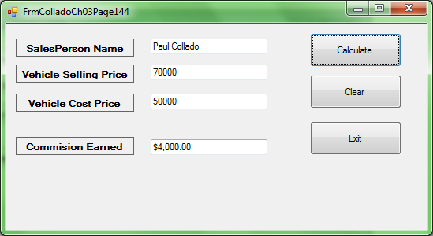

Public Class FrmColladoCh03Page144

Private Sub BtnCalculate_Click(ByVal sender As System.Object, ByVal e As System.EventArgs) Handles BtnCalculate.Click
Const CommisionRate As Decimal = 0.2D
Dim SalePrice As Decimal = Val(Me.TxtSellingPrice.Text)
Dim CostPrice As Decimal = Val(Me.TxtCostPrice.Text)
Dim Commision As Decimal

Commision = CommisionRate * (SalePrice - CostPrice)

Me.TxtCommision.Text = FormatCurrency(Commision)

Try
Me.TxtSellingPrice.Text = CDec(Me.TxtSellingPrice.Text)
Catch ex As Exception
MessageBox.Show("Please try again, enter an number and click calculate again", "ERROR")
Me.TxtSellingPrice.Clear()
End Try

Try
Me.TxtCostPrice.Text = CDec(Me.TxtCostPrice.Text)
Catch ex As Exception
MessageBox.Show("Please try again, enter an number and click calculate again", "ERROR")
Me.TxtCostPrice.Clear()
End Try

End Sub

Private Sub BtnClear_Click(ByVal sender As System.Object, ByVal e As System.EventArgs) Handles BtnClear.Click
Me.TxtSalesPerson.Clear()
Me.TxtSellingPrice.Clear()
Me.TxtCostPrice.Clear()
Me.TxtCommision.Clear()
End Sub

Private Sub BtnExit_Click(ByVal sender As System.Object, ByVal e As System.EventArgs) Handles BtnExit.Click
Me.Close()
End Sub

Private Sub FrmColladoCh03Page144_Load(ByVal sender As System.Object, ByVal e As System.EventArgs) Handles MyBase.Load

End Sub
End Class

